Dundee Outdoor Learning and Play Collegiate Group

Terms of Reference

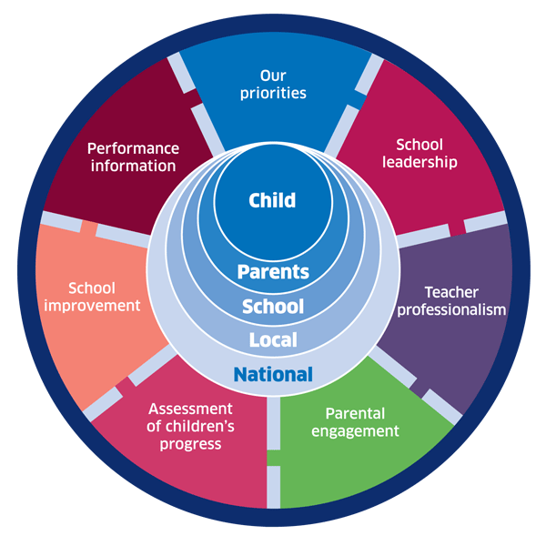 | 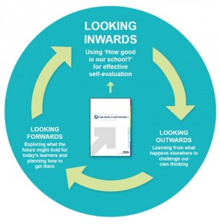
National Improvement Framework  http://www.gov.scot/Publications/2016/01/8314 | HGIOS 4 Self-evaluation https://education.gov.scot/improvement/Documents/Frameworks_SelfEvaluation/FRWK2_NIHeditHGIOS/FRWK2_HGIOS4.pdf | Tayside Plan C&FS  External Link 'Tayside_Plan 1a.pdf'

AIM
“To support all Collegiate Group schools to embed a whole school approach to outdoor learning and play as part of the priorities within their school improvement plan by June 2019”

IMPROVEMENT PRIORITIES of the Outdoor Learning and Play Collegiate Group

- Flexible outdoor learning and playful environments for the school and community.
(Funding and redevelopment of playgrounds)

- Increased teacher/support staff awareness and understanding of Outdoor learning and Play

- Increased teacher/support staff confidence and skills to take learning outdoors

- Removing the barrier to Outdoor Learning and Play – Health and safety, solutions to going outside in Scottish weather

MEETINGS

The group meet once per term (4 times per year). Members volunteer for short term task groups to progress the above priorities. The meetings are interactive and informative with minutes of actions produced following each meeting.

MEMBERSHIP

1 | Ancrum Primary | Clare Angus |  | Clare.angus@dundeecity.gov.uk
2 | Ardler Primary School | Louise Reid, HT |  | Louise.reid01@dundeecity.gov.uk
3 | Ballumbie Primary | Kim Flynn |  | Kim.flynn@dundeecity.gov.uk
4 | Barnhill Primary | Angela Bruce, HT  Lois Maxwell |  | angela.bruce@dundeecity.gov.uk  DDlmaxwell115@glow.sch.uk
5 | Blackness Primary | Lynsey McLaren, PT |  | Lynsey.mclaren@dundeecity.gov.uk
6 | Claypotts Castle Primary | Susan Walker, HT  Andrew Blacklaw, ADHT |  | Susan.walker@dundeecity.gov.uk  Andrew.blacklaw@dundeecity.gov.uk
7 | Craigiebarns Primary | Alison Watt, CT  Sandie Storrier, CT |  | ddawatt307@glow.sch.uk  ddsstorrier329@glow.sch.uk
8 | Craigowl Primary | Euan Smith, HT  Karen Ramsay, PT |  | euan.smith@dundeecity.gov.uk  karen.ramsay@dundeecity.gov.uk
9 | Dens Road Primary | Ann Marie McDonald, HT  Graeme Robertson  Laura Dall  Martin Downie, DHT  James Stewart, Class Teacher |  | annmarie.mcdonald@dundeecity.gov.uk  ddgrobertson453@glow.sch.uk  ddldall839@glow.sch.uk  martin.downie@dundeecity.gov.uk  ddjstewart442@glow.sch.uk
10 | Glebelands Primary | Robert Gill, HT |  | robert.gill@dundeecity.gov.uk
11 | Kingspark School | Paul Dow, DHT |  | paul.dow@dundeecity.gov.uk
12 | Mill of Mains Primary | TBC
13 | Rosebank Primary | Jennifer Heffell, HT |  | jennifer.heffell@dundeecity.gov.uk
14 | Rowantree Primary | Tina Ross, DHT |  | christine.ross@dundeecity.gov.uk
14 | SS Peter and Paul RC Primary | Denise Derby, Acting HT |  | denise.derby@dundeecity.gov.uk
15 | St Joseph’s Primary | Lorna Dashwood, DHT |  | Lorna.dashwood@dundeecity.gov.uk
16 | St Mary’s RC Primary | Liz Conroy, HT  Carolyn Lothian, DHT |  | liz.conroy@dundeecity.gov.uk  carolyn.lothian@dundeecity.gov.uk
17 | St Ninian’s Primary | Lisa MacPhail, HT  Mark McCormack |  | lisa.macphail@dundeecity.gov.uk  ddmmccormack179@glow.sch.uk
18 | St Pius RC Primary | Danny Albayati |  | dddalbayati277@glow.sch.uk
19 | St Vincents Primary | Gillian Robertson, APT |  | Ddgrobertson546@glow.sch.uk
19 | Sidlawview Primary | Denise McCaffery, HT  Elaine Dailly |  | denise.mccaffery@dundeecity.gov.uk
20 | Victoria Park | Lesley Anne Weir |  | lesleyanne.weir@dundeecity.gov.uk
21 | Staff Tutor (Numberacy) | Audrey Cox(TBC)  Sasha Devlin  Emma Kidd |  | audrey.cox@dundeecity.gov.uk  sasha.devlin@dundeecity.gov.uk  emma.kidd@dundeecity.gov.uk
22 | Ancrum Outdoor Learning | Derek Napier |  | derek.napier01@leisureandculturedundee.com
23 | Health & Wellbeing Development Worker | Rachel Watson |  | Rachel.waton@dundeecity.gov.uk
CHAIR |  |  | Angela Bruce |  | angela.bruce@dundeecity.gov.uk
LEAD OFFICER SUPPORT |  |  | Audrey White, Senior Officer Health & Wellbeing |  | audrey.white@dundeecity.gov.uk

GOVERNANCE
The Outdoor Learning Collegiate Group reports directly to the Children and Families - Health and Wellbeing Strategy and Action Group. The work of the group is a key delivery vehicle of the Dundee Play Framework, (priority 2) and therefore also reports into the Play Leadership Group and subsequently to the Children and Families Executive Board.

CONTEXT

The priorities for school improvement are grounded in the National Improvement Framework, self-evaluation framework, the Local Outcome Improvement Plan (LOIP), the Tayside Plan for children, young people and families and further exemplification in HGIOS4

NIF PRIORITIES:
- Improvement in attainment, particularly in literacy and numeracy;
- Closing the attainment gap between the most and least disadvantaged children;
- Improvement in children and young people’s health and wellbeing, and;
- Improvement in employability skills and sustained, positive school leaver destinations for all young people

Local Authority ambition:

“Our children and young people will have the best start in life and Tayside will be the best place in Scotland to grow up.”

Local Authority aims:
- Our children will have the best start in life; they will be cared for and supported to live in nurturing environments.
- Our children, young people, and their families will be meaningfully engaged with learning, and combined with high quality learning experiences, all children and young people will extend their potential.
- Our children and young people will be physically and mentally and emotionally healthy.
- Our children and young people who experience particular inequalities and disadvantage will achieve health, wellbeing and educational outcomes comparable with all other children and young people.
- Our children and young people will feel safe and protected from harm at home, school and in the community.

